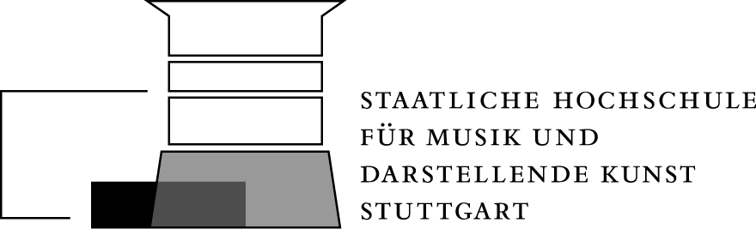

Urbanstr.25, 70182 Stuttgart Tel: 0711/212-4650, Fax: 0711/212-4639
Internet: http://www.hmdk-stuttgart.de, e-mail: bettina.roeser@hmdk-stuttgart.de

Registration for Entrance Exam: Summer Semester ........... / Winter Semester ...........

The following documents must be included in the application
High-School graduation diploma 1 passport picture Curriculum vitae
Performance records from previous studies Bachelor's / Master's Diploma
Proof of payment of the registration fee of 50 € per transfer to: LOK BA-WÜ/HMDK Stuttgart IBAN:
DE 02 6005 01017495530102, BIC-CODE: SOLADEST600.
Purpose: 8587200001142 + Last Name, First Name – please specify!

...........................................................................................................................................................................................................................................

Surname First name

……………………………………………………………………………………………………………………………………………………………………………..
Postcode, residence Street

Phone..................................................................................... e-mail address:...............................................................................................................

Registering for Entrance Exam in

Major Subject................................................................................................. .Degree ..................................................................

Requested Main Teacher .......................................... (without entitlement to consideration)

PERSONAL DATA

Date of birth.................................................................... Place of birth................................................................ Denomination......................................
(Only when registering for church music)

Education.......................................................................................................................................... Nationality........................................

School exams: Elementary School..................................... Middle School ........................................... High School.............................................................

Comments..............................................................................................................................................................................................................

…………………………………………………………………………………………………………………………………………………………………………

..................................................................................................................................................
Date and signature of the applicant

